5/6BT Homework – Term 4 Week 2
Spelling

thirteenth | twentieth | nineteenth | fifteenth | seventeenth
symptom | contempt | exempt | unkempt | emptiness
unknowingly | untidily | uncurl | unaccompanied | unacceptable
utility | utilise | utilitarian | utilisation | utilisers
aisle | delirious | epilepsy | eucalypt | acquisitive
beneficiary | extravagance | cauliflower | gratuitous | idiosyncratic

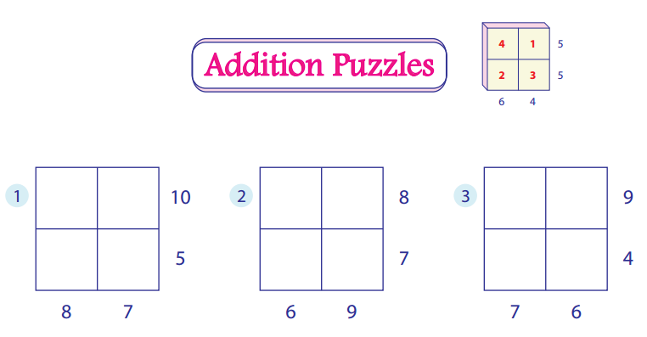
Brain Teaser
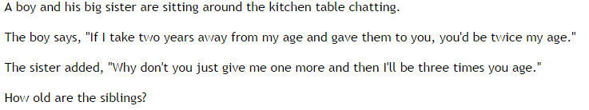

Reading Log

Title:_____________________

Pages Read:____________________________

What do you enjoy about this book?

_____________________________________________________________________________________________________

_____________________________________________________________________________________________________

____________________________________________________________________________________________________

