5/6BT Homework – Term 4 Week 3
Spelling

guilty | hygiene | favourite | leisure | admittance
thumb | chalk | answer | descend | muscle
intolerant | irresponsible | irrational | irregular | inexpensive
hydrogen | hydrolysis | hydrophyte | hydrophobia | hydrography
gargoyle | pigeons | fervently | reiterates | urchin
exhausted | tentacle | personification | insinuate | euphemism

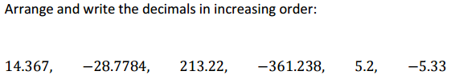

___________________________________________________________________________________________________

____________________________________________________________________________________________________

Brain Teaser

Reading Log

Title:_____________________

Pages Read:____________________________

What do you enjoy about this book?

_____________________________________________________________________________________________________

_____________________________________________________________________________________________________

____________________________________________________________________________________________________

