5/6BT Homework – Term 4 Week 4
Spelling

quite | quiet | nephew | league | interrupt
conceit | priest | phoenix | thief | achieve
disbelief | impose | impulse | disappear | disruptions
dormient | dormancy | dormitory | dormitories | dormant
discrepancy | colloquialism | rebellious | prosciutto | physique
facetious | assassinate | orthodox | circumstantial | affiliate

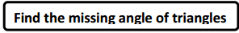
The Bridge Riddle

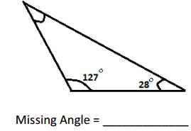
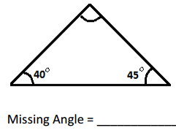

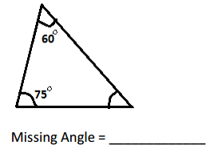
Brain Teaser

The Bridge Riddle

After watching the video from our website you need to add your answer to the blog post.

Reading Log

Title:_____________________

Pages Read:____________________________

What do you enjoy about this book?

_____________________________________________________________________________________________________

_____________________________________________________________________________________________________

____________________________________________________________________________________________________

