5/6BT Homework – Term 4 Week 5
Spelling

ski | occurred | accommodation | daughter | aluminium
croup | manoeuvre | shoe | goulash | canoe
you’re | they’ve | could’ve | can’t | aren’t
monopoly | monolith | monody | monocular | monolingual
notorious | opulently | debacle | fictitious | statuesque
therapeutic | rhetorical | orienteering | cappuccino | adolescence

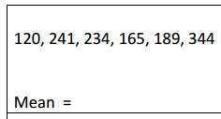
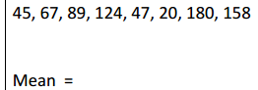

Brain Teaser

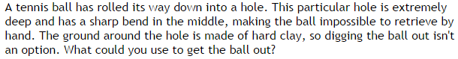

Reading Log

Title:_____________________

Pages Read:____________________________

What do you enjoy about this book?

_____________________________________________________________________________________________________

_____________________________________________________________________________________________________

____________________________________________________________________________________________________

